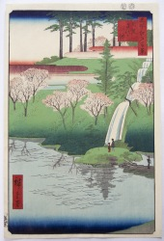
Reflections of a Summer Scape
Japanese Clay, Prints and Paintings

June 20 – August 17 2018
Joan B. Mirviss LTD 39 E. 78 Street, NY, NY 10075

Joan B. Mirviss is pleased to present Reflections of a Summerscape: Japanese clay, prints, and paintings from June 20 to August 17, 2018. The exhibition is inspired by the colors and elements of the Japanese summer landscape from the sweltering heat of the mid-day sun to the blue–green of water, the vibrant reds of the peonies, the creamy tones of the abalone shells, the granular patterns of sand, and the smooth, carved surfaces of viewing stones.
Utagawa Hiroshige
(1797-1858)
100 Views of Edo: Chiyogaike
Wood block print
1856, 7th month

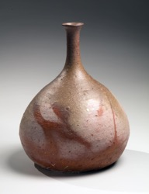
Summer in Japan is generally scorching with the only relief from the heat being the cool clear nights. The colors red and yellow developed associations with the searing summer days while blacks and cool blue-greens became linked with the soothing temperatures of the nighttime. These colors were codified during the Heian period (794-1185). In the Edo period, firmly established colors and plant motifs came to signify specific times of the year. For June the plant was artemisia, the colors sprout green and yellow; for July, the lily and the colors red and dead-leaf yellow; and finally for August, cicadas (in particular their wings) and the colors sky blue and cedar bark.

In Reflections of a Summerscape, we showcase clay works, prints and paintings that reflect the aesthetic of the Japanese summer, drawing on the associated colors as well as textures which reference the landscape’s physical attributes. Thus a work by Makuzu Kōzan II (1859-1940) with it’s bright yellow and cobalt blue floral patterns are featured along with subtler references such as the creamy white of a Ide Teruko (b. 1947) bowl or the fiery salmons and pinks of a Mori Tōgaku (b. 1937) vase. The ceramics’ colors are enhanced and echoed by the borrowed views of foliage and buildings from nearby Madison Avenue through the gallery’s windows. Additionally, we have chosen woodblock prints by Ohara Koson (1877-1945), Kawase Hasui (1883-1967) and Utagawa Hiroshige (1797-1858) for their depictions of summer themes such as verdant landscapes or birds and flowers. Paintings of early summer flowers by Yamamoto Baiitsu (1783-1856) and the summer moon in the cool of evening by Takeuchi Seihõ (1864-1942) complete our gallery “summerscape”.
Mori Tōgaku (b 1957)
Crane-necked
Turnip-shaped Vase
Bizen stoneware
2015

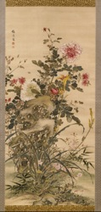
About Joan B. Mirviss LTD

Joan B. Mirviss has been a distinguished expert in Japanese art, specializing in fine art and ceramics for more than forty years. She is the leading Western dealer in the field of modern and contemporary Japanese ceramics, and from her New York gallery on Madison Avenue, JOAN B MIRVISS LTD exclusively represents the top Japanese clay artists. As a widely published and highly respected specialist in her field, Mirviss has advised and built collections for many museums, major private collectors, and corporations. For further information or images, please call 212-799-4021 or email admin@mirviss.com
Yamamoto Baiitsu
(1783-1856)
Early Summer Flowers
Ink and color on silk
Hanging Scroll
Ca. 1840-50

